**Safety Bay SHS**

**Physics - Unit 1 – Task 4**

**Electricity Test**

**Name: Total Marks /46**

**Question 1:**

A way to “zap” your friends is to rub your feet on a carpet in summer so as to build up a charge, then you touch a friend and they get “zapped”. Why do you build up a charge when you rub your feet on carpet and what causes the “zap” when you touch your friend? **[3 marks]**

**Question 2:**

Label the following circuit to show the direction of electron current. **(1 mark)**

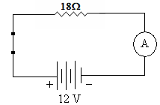

**Question 3:**

A lightning bolt contains 6.0 x 109 J of energy which is enough to power a city. If it transfers 30 C of charge to the Earth in 1.5 ms,

a. what was the potential difference produced by the lightning bolt? **(2 marks)**

b. What is the average power dissipated during the strike? **(2 marks)**

**Question 4:**

1. force of 8.50 x 10-3 N attraction is felt between two charged spheres that are 45 cm apart. If one has a charge of + 0.3 μC, what is the charge on the other? **(3 marks)**

* 1. The two spheres are then forced together and allowed to separate to a distance of 30 cm apart. What is the force between the two spheres now? **(2 marks)**

**Question 5:**

1. A student completes a circuit that includes a mystery box as shown below.

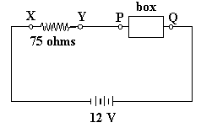

If the potential difference between *X* and *Y* is 9.0 volts, which of the following boxes (A - D) is in

the circuit? **(3 marks)**

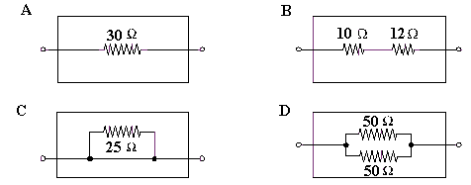

*This space has been left for any working you need to perform.*

**Question 6:**

1. You are given the following component.

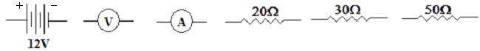

*Read all the instructions before you draw the circuit.*

Use these components to draw an electrical circuit where the 30Ω and 20Ω resistors are in series. Place the 50Ω resistor in parallel with both of these resistors. Place the voltmeter to measure the potential difference of the 30Ω resistor only and the ammeter to measure the current of the 20Ω resistor only. The battery supplies energy to the whole circuit. **(4 marks)**

**Question 7:**

A rechargeable battery was charged at a constant current of 600 mA for 9 hours. The average cell potential difference during the re-charge was 1.6V.

1. Calculate the amount of charge that passed through the cell. **(2 marks)**
2. Calculate the amount of work done by the charging device. **(2 marks)**

**Question 8:**

Tom was given four 3.00 Ω resistors. Draw a diagram below to show how he could connect the four resistors to give a total resistance of 4.00 Ω. **(2 marks)**

**Question 9:**

A child’s toy robot requires 4.50 V to run. The batteries supply a current of 3.00 x 102 mA and a power output of 1.35 W. Calculate the electrical resistance of the robot. **(2 marks)**

**Question 10:**

The element of an electric jug has a resistance of 60.0 Ω and draws a current of 3.75 A. 1.05 kg of water at a temperature of 200C is in the jug. How long will it take to bring the water to the boil (1000C)? Give your answer in minutes. *HINT* use heat equations **(4 marks)**

**Question 11:**

A year 12 Physics student is trying to find a quiet place to study, so moves into a shed in the back yard. He doesn’t want to do without modern conveniences so gets a long extension cord from his parents’ place to the shed. He uses a power board to plug in all the appliances. The shed now has 240V supplied to:

* + 60W light bulb in a lamp
  + 1000W bar heater
  + 750W microwave

1. The power board has a fuse rated at 10A, does it trip if all of the appliances are turned on?

**[3 marks]**

1. Calculate the resistance of the 750W microwave. **[2 marks]**
2. When all the devices are operating, how does the total resistance of the circuit compare to that of just the microwave? (No calculations required) **[1 mark]**

Circle the correct answer: GREATER EQUAL SMALLER

1. The element of the heater is a non - Ohmic conductor. Just after it is turned on it begins to increase in temperature and the current drawn changes. Use the Kinetic Theory to explain what happens to the current (and therefore resistance) as the element warms up to operating temperature. **[3 marks]**

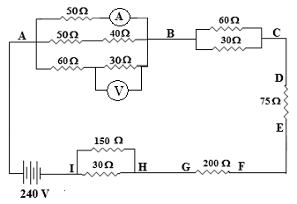**Question 12: (DO THIS QUESTION LAST)**

Find the reading on the two metres. **(5 marks)**